There are two stages to completing IDL discharge paperwork.
- A letter is generated summarising reason for admission and/or birth details, follow up plans and key details. This is sent to the woman’s GP. A midwife may draft a letter for any woman.
- For women who require medications at point of discharge an IDL is also required. IDL’s may be completed by midwives or medical staff dependent on their obstetric and medical history and if the necessary medications are within the Midwifery Formulary.

Documenting “suitable for midwife-led discharge”
Following review by medical staff if a woman is deemed suitable for midwifery led discharge this should be documented clearly by medical staff within progress notes.
This then allows midwives to complete discharge letter, IDL and supply formulary medications
Request review within doctors’ diary if women not immediately suitable for midwife-led discharge, but may be if approved by medical staff
Before starting IDL it is useful to have the following:
- Baby Discharge Summary
- Woman’s Weight
- Current Hb
- Contraceptive preferences
- Follow up plans

To add medication to the IDL as a midwife
- Complete Midwifery Formulary and PGD training (Learnpro and face to face)
- Have face to face training, if needed, to support creating IDLs

IDL QUICK CODES
\svd
\forceps
\ellucs
\emlucs
\tear
\hyperem
\fetalloss/MTOP
\anadm
\pnadm
\debrief

This is not an exhaustive list and any concerns should be discussed between Midwifery and Obstetric Staff.
In most situations if a review has been carried out by medical staff who determine that the patient is suitable for midwife-led discharge this should be clearly documented within the progress notes.

Doctor-led IDL | Midwife-led IDL
Medication outside Midwifery Formulary – when medications are added this letter should be printed and signed by doctor adding.  Any other medications that were within formulary could be then added by midwife and signed and this letter stapled to the original letter | Antenatal patients where doctor has documented “suitable for midwife-led discharge”
3° and 4° tears – and to arrange follow up | Postnatal patients where doctor has documented “suitable for midwife-led discharge”
Rotational assisted vaginal deliveries including KRFD and Ventouse | Patients who have been in HDU where doctor has documented “suitable for midwife-led discharge”
EMCS – should have review and if “suitable for midwife-led discharge” this should be documented within progress notes | Postnatal readmissions – when medications are on formulary
ELCS – with additional complications | SVD with EBL ≤1000ml
Neonatal Unit admission – where admission due to maternal health/complications eg unexpected admission to neonatal unit or preterm birth. Should have review and if “suitable for midwife-led discharge” this should be documented within progress notes | Uncomplicated WFD/HFFD/Kiwi with EBL ≤1000ml
Maternity HDU admission – if not suitable for midwife-led discharge. These women should be reviewed on postnatal ward and plan of care made. | ELCS with EBL ≤1000ml and documented “suitable for midwife-led discharge”
PPH >1000ml | Midwives can amend and add to doctor created IDLs.  - If medicines on original IDL include ones not on midwifery formulary this must be printed and signed by doctor.  - If medicines within formulary this can be signed as supplied by midwives.  - IF midwife can add medication within formulary to a IDL where doctor has had to sign then a copy should be printed, the medicines supplied by the midwife signed and then staple to the original letter to go to pharmacy.
Incontinence – faecal and persistent urinary
Complex medical history – should have review and if “suitable for midwife-led discharge” this should be documented within progress notes
Medical complications of pregnancy eg. Hypertension
Fetal Loss, IUD, MTOP

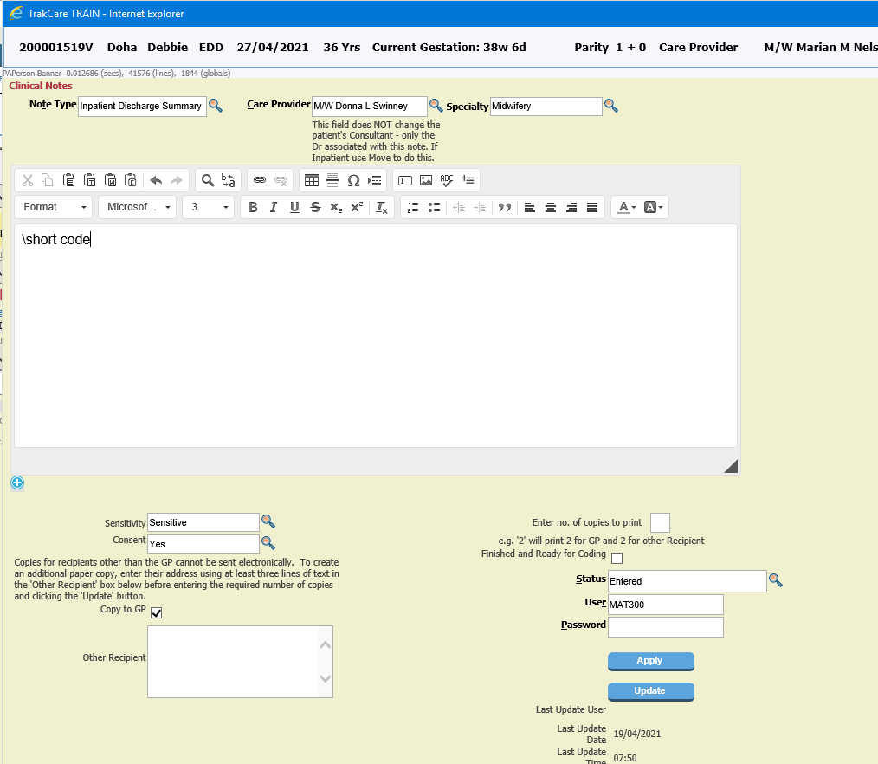
3. Select Inpatient Discharge Summary from the drop down list
4. Type the quick code from the list below by typing \quick code then press space bar.
This will then display the text for the appropriate letter for you to then complete with patient details
IDL QUICK CODES

\svd \forceps
\ellucs \emlucs
\tear \hyperem
\fetalloss/MTOP
\anadm \pnadm

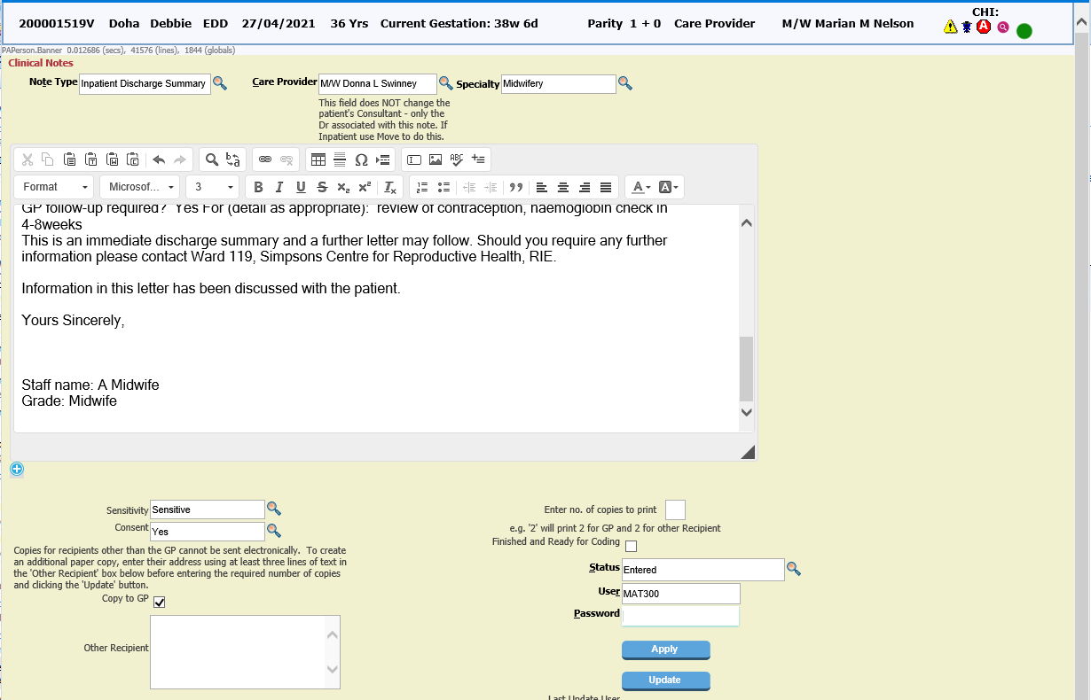
6. Once completed letter enter password and update.

If completing draft at top of letter type ***DRAFT*** to make clear amendments are needed
5. Complete the questions and fill in patient’s information.

At this stage once letter is complete – discharge medication needs to be ordered
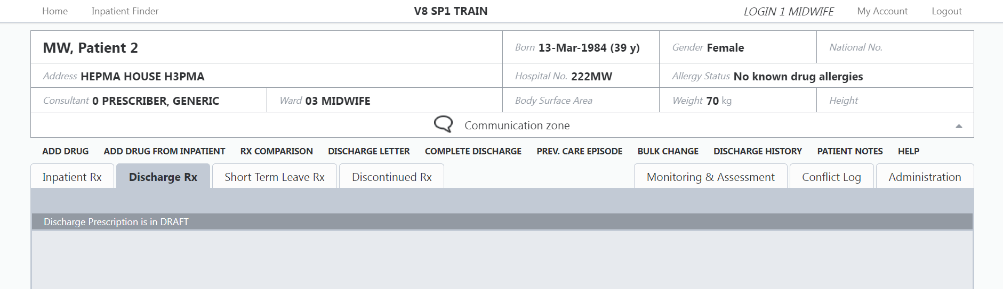
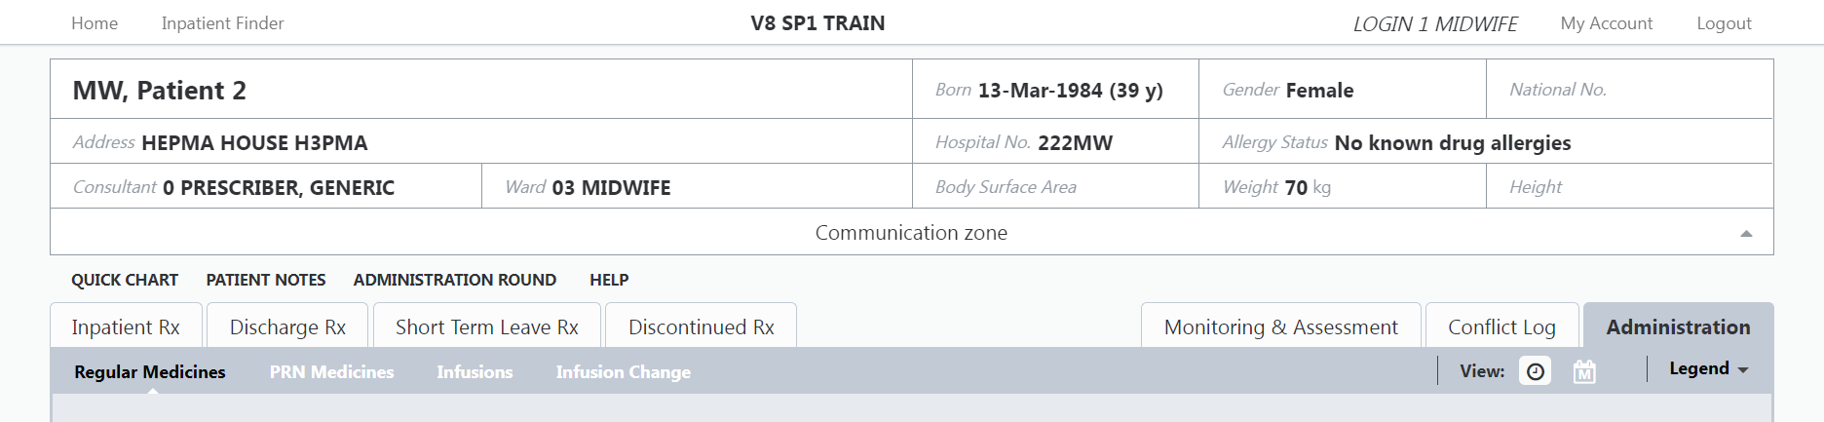
7. Log into HEPMA for the patient you are planning to discharge. Click Discharge Rx to start adding medications as per NHS Lothian Prescription and Administration Record (Drug Chart) and within Midwifery Formulary and PGD which you are trained to supply.
8. If the patient has been supplied with regular/PRN medication whilst inpatient that are suitable for midwifery supply then these can be added by selecting Add Drug From Inpatient.

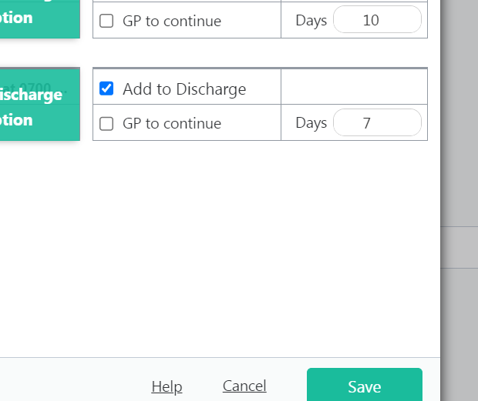
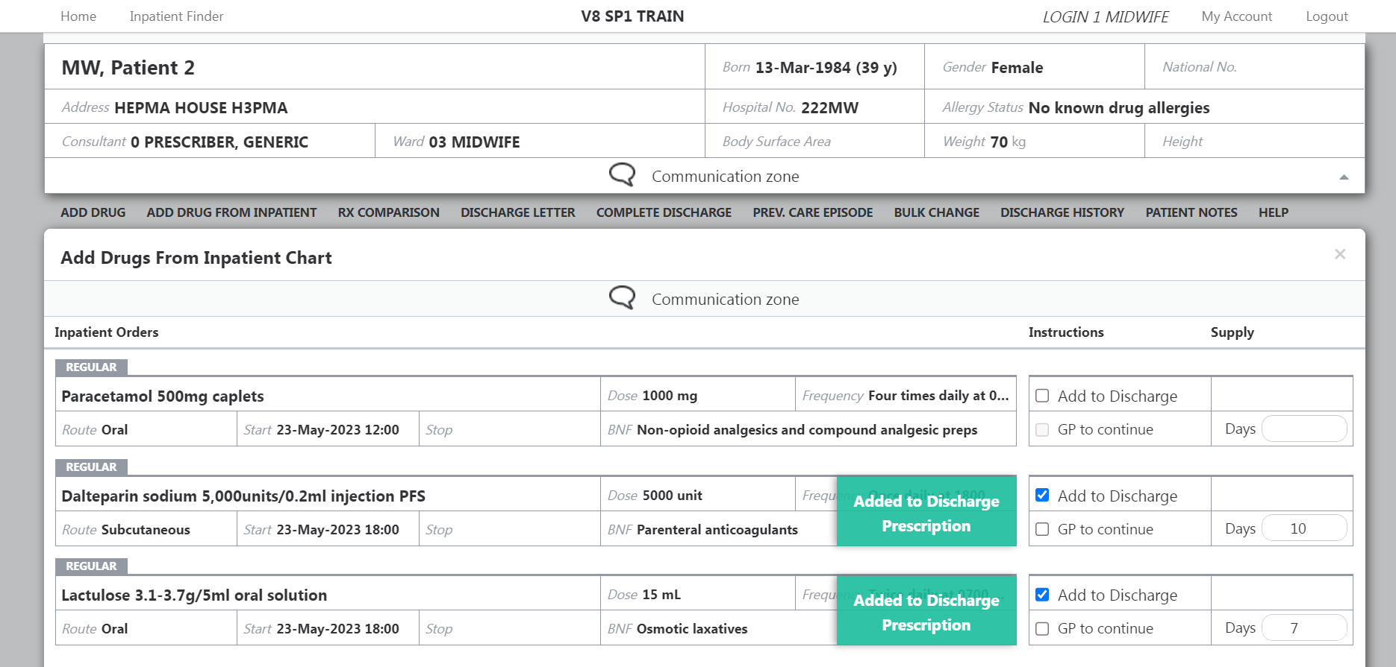
10. Then select Save
9. Any inpatient regular/PRN medications will then appear. Select Add to Discharge for meds required for discharge (if suitable for midwifery supply)
Then select whether the GP to Continue and the length of supply to be provided in Days.

Once complete click Update
This will return to the previous screen and you can add next medication.
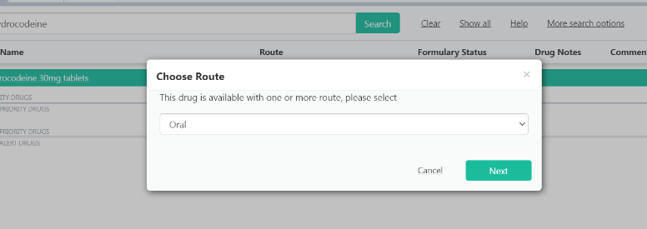
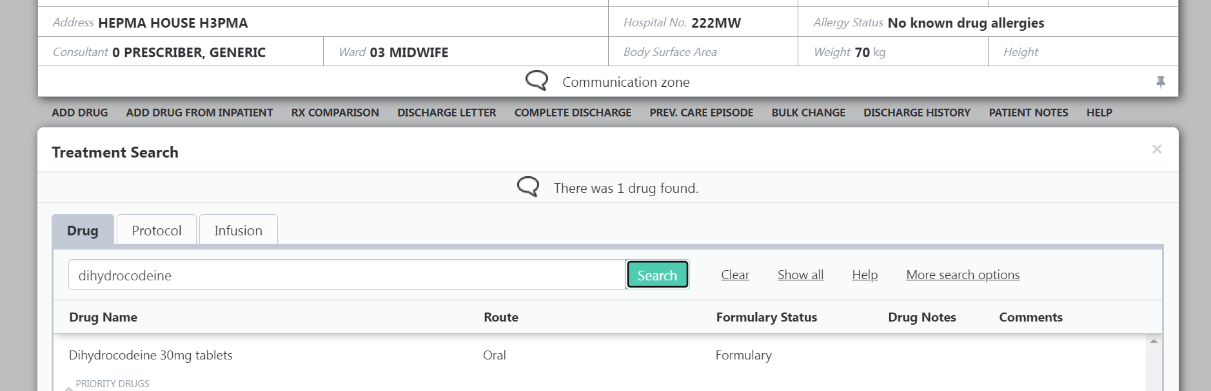
12. Search for and choose suitable medication

11. If no inpatient regular/PRN medications, or if additional medications suitable for Midwifery supply to be added, then select Add Drug

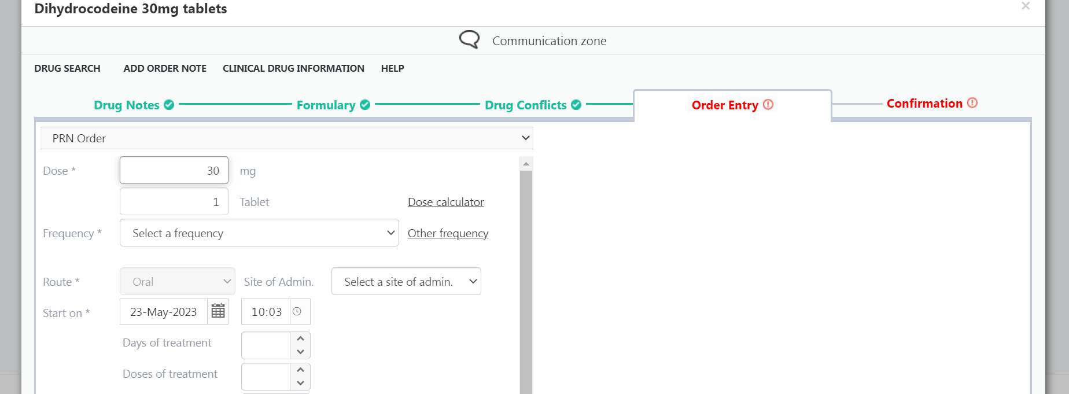
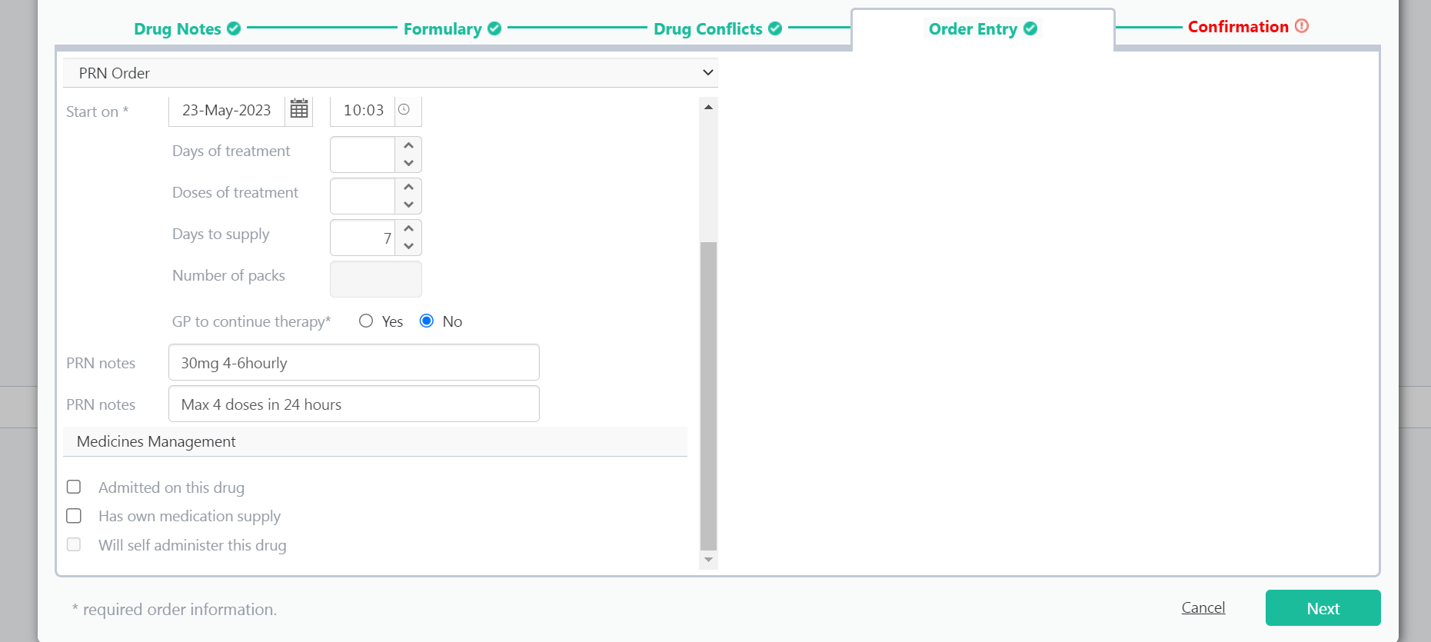
13. Choose whether Regular or PRN order and Frequency if suitable.
Select whether GP to continue therapy
If PRN medication, then input suitable frequency advice into PRN notes.
Then select Next

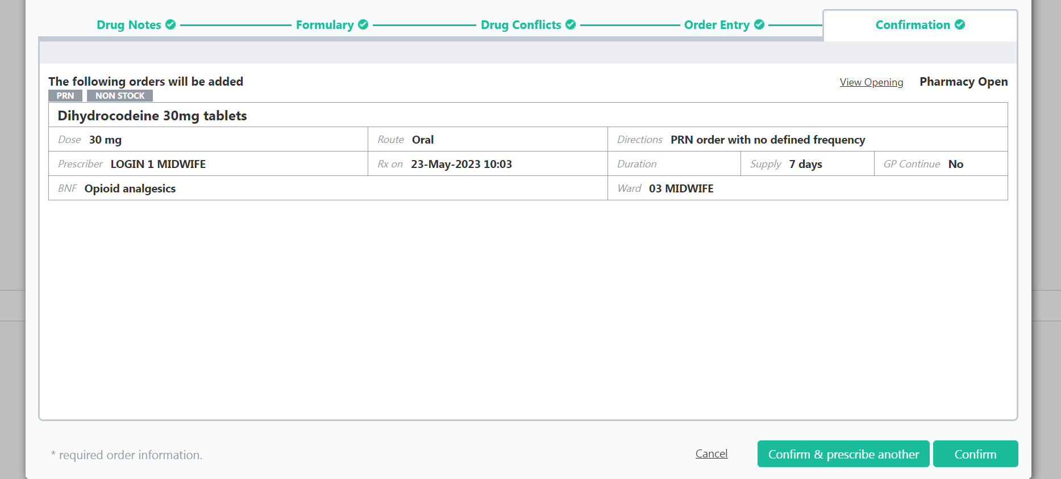
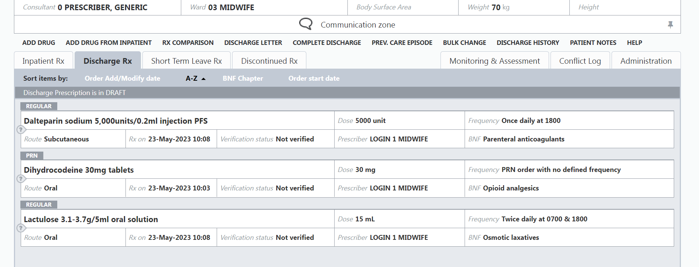
15. Once you have selected Confirm, you will then see all the medications that have been selected for discharge.

14. If you have added all necessary medications then select Confirm.
If you wish to add further medications, then select Confirm & prescribe another and follow the same procedure as before.

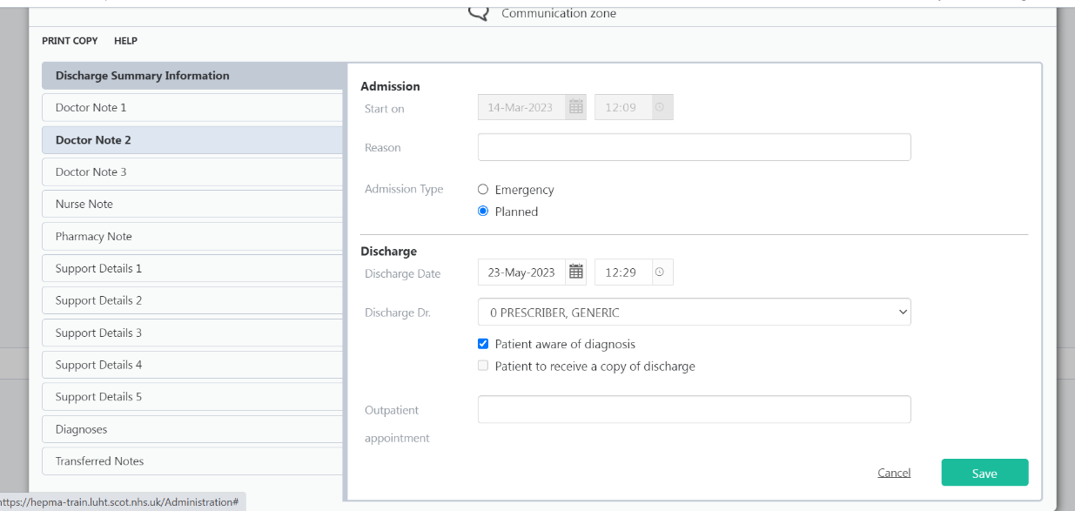
17. Choose appropriate medical staff or Generic Prescriber

16. To add discharge medications to Trak IDL, select Discharge Letter.

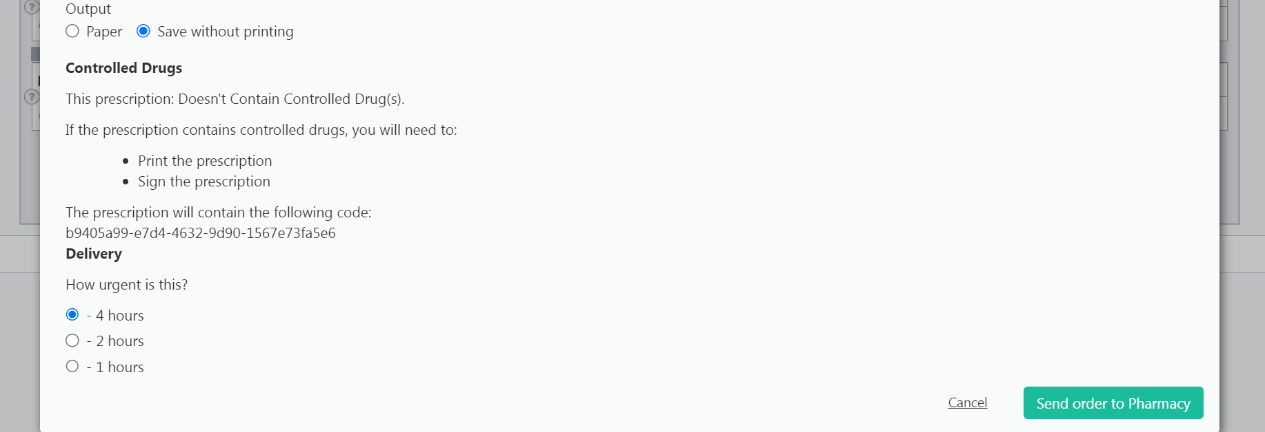
17. Then select Save without printing, and then Send order to Pharmacy (within maternity this does not actually send the order to pharmacy, but it does upload the medications to the Trak IDL)

17. Then select Complete Discharge.

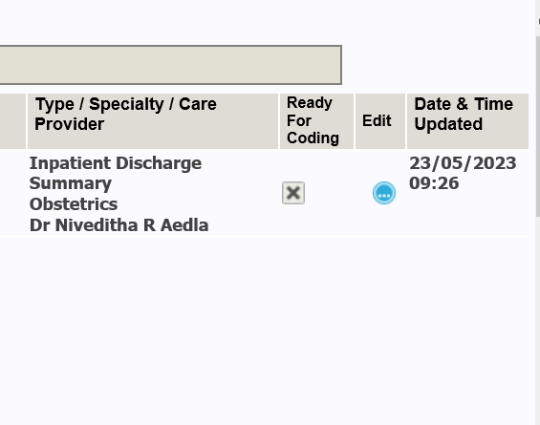
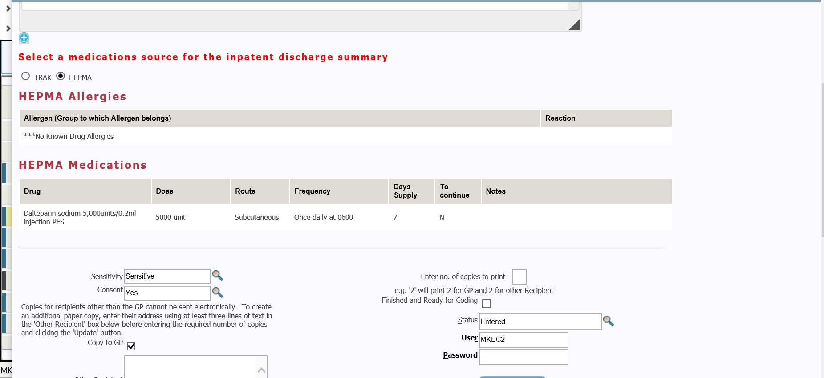
18. Go back to the IDL and select Edit
100
19. You will be alerted that the medications have been changed.
They will appear the bottom of the IDL, with the medication source labelled as from HEPMA
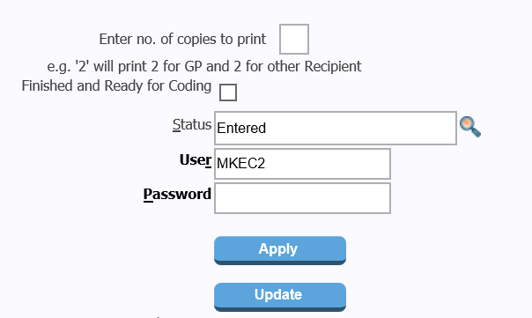
4
20. To print copies of the IDL - enter how many copies you require (usually x4 copies = x1 to be signed for pharmacy, x1 for the patient, x1 for the blue maternity notes, x1 for the GP). Then enter your password and select Apply.

